Summary of Findings from the Opening Conference in Cavriago
- Background
During the 4th event for Project “BEYOND”, which was held in Cavriago, Italy from November 13th to 15th, 2023; one of the important activities during the event was gathering citizens’ opinions and views on the impacts the COVID-19 pandemic had on the mental health of citizens. During the opening conference on Monday November 13th 2023 at the Multiplo Cultural Centre, a Slido survey was conducted with participants as means to stimulate discussion about the impacts of the COVID-19 pandemic on mental health in the community. Through the collection of these data, the partnership aims to develop new projects and approaches for their communities that better promote social inclusion and mental health for all citizens.
- Survey results – Slido
The survey was conducted electronically, and the participants took part in the survey via a link sent to their mobile phones. 37 persons took part online and those who couldn’t access the survey (due to not having their phone available, not being able to connect to the internet, or not having a smartphone) contributed to the discussions. In total there were five key questions asked to the participants.

The opening question for participants was “What word describes how I felt during the pandemic?” The purpose of this question was to quickly have participants summarize whether the pandemic had a positive or negative impact on them. The answers are shown below:

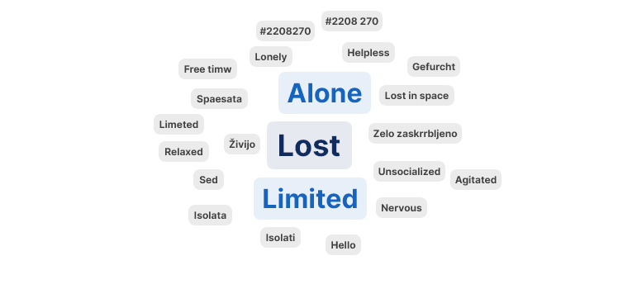
The majority of participants gave regarded the pandemic as a negative phenomenon. Many felt lost, limited and/or alone. It should be mentioned that some participants found it as a time to relax. They mentioned that prior to the pandemic their lives were overwhelming and the sudden halt of all activities at the start of the pandemic gave them time to pause. Despite these “benefits” though, for the most part participants mentioned that it complicated their lives due to the restrictions and limits they face.

The second question was “What word describes how I feel now (after the pandemic)?“ The purpose of this question was to determine whether the post-pandemic period has been of benefit or harm (mentally) to participants. The following answers were provided:

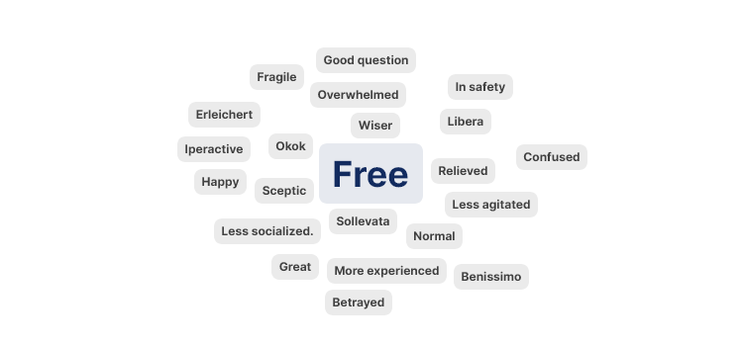
The majority of the answers were positive (e.g. free, normal great, etc.), but at the same time many answers indicated that participants were not feeling well in this post-pandemic period (e.g. betrayed, less socialized, overwhelmed). While the restrictions during the pandemic have mostly been repealed, the problem for many was that a sudden change happened. The pace of life picked up drastically which led to new stress. Overall, all participants agreed that they are still adjusting to the new normal and that more mental health initiatives for the community are needed.

The third question was “How did I cope or adapt to the pandemic?”. The purpose of the question was to discuss how citizens functioned during the pandemic. The participants had the following multiple choice options and provided the following answers:
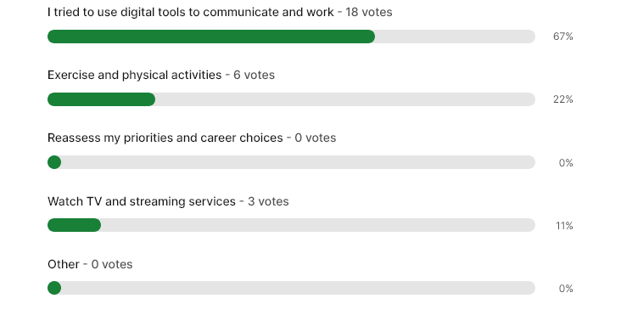

The participants all agreed that digital tools were the main means to keep the community activities going during the pandemic. Without online meetings, enhanced internet connections, teleconferences, etc. citizens agreed that they probably would not have been able to cope with the circumstances of the pandemic. Physical exercise was also mentioned as a means to keep the mind and body healthy.

The fourth question was “Has life in the community returned to normal in the post pandemic period?”. The participants provided the following answers:

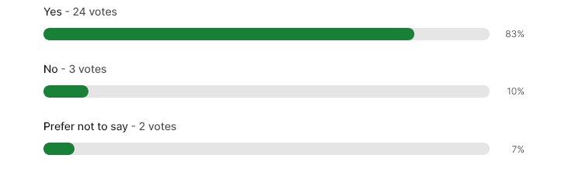
The participants explained during the discussion that the community has returned to normal in the sense they can access services in-situ, they no longer need to have everything online, and they can freely travel from point A to point B. However, many participants mentioned that they were still wary/worried that the pandemic would come back. Unlike before, citizens are more careful abut their health and how they interact with others.

In the last question “How can local governments help citizens “return to normal”?”, the idea was gather opinions and feedback from citizens about the role of local governments in promoting mental health in the community. The participants were provided multiple choice questions and answered the questions. The answers are found below:

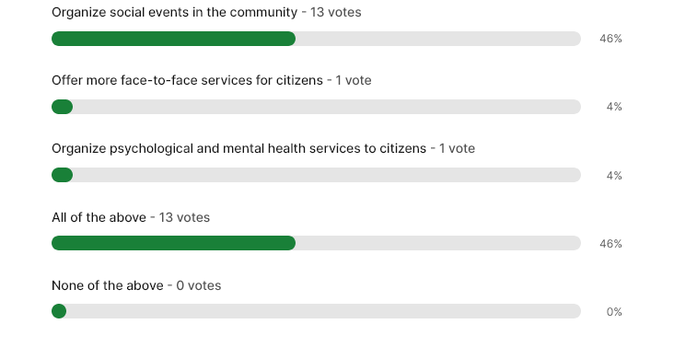

The participants mainly thought that social events in the community would be the most helpful step. Participants mentioned that they do not want to be told that they need help. They don’t want to told that they are damaged or unhappy. Social events allow citizens to engage, meet others, communicate and this ultimately leads to citizens becoming happier (i.e. mentally well). Direct psychological services were regarded as a service that could be accessed (and of help) by the most desperate, but it may not be of interest to those who do not believe they need such support. In other words, if don’t see that they have a problem, they will not access the proposed solutions.

- Conclusions

Based on the responses received, it can be concluded that despite the COVID-19 pandemic being declared over, citizens are still struggling to “get back to normal.” They are wary of COVID-19 and the possibility of the next global event despite the fact services are being delivered in the same way as before the pandemic, and restrictions have been lifted. Many mentioned that in order to promote mental health in the community (and resilience in the community), the community needs to come together. Social events as opposed to psychological services are regarded as a much better solution to citizens (in terms of mental well-being) as they encourage us to join together, interact and move on with our lives. It was concluded that activities that bring citizens out of their homes (i.e. promoting volunteering, learning new skills, social events) and into the community are the most beneficial activities for citizens, in terms of promoting mental health and enhancing citizens’ sense of identity in the community.

